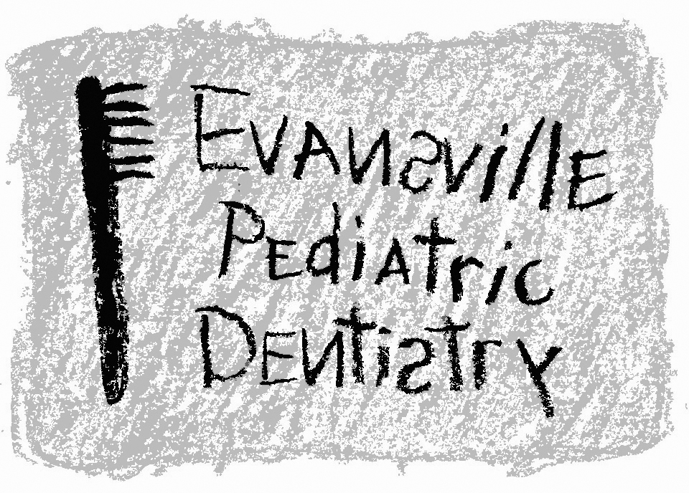
Jeffrey A. Hiester, D.D.S.
EAST WEST
7200 E. Virginia Street 2345 W. Franklin Street #101
Evansville, IN 47715 Evansville, IN 47712
(812) 479-8609 (812) 401-6095

Office Philosophy

Our pediatric dental practice is a specialty practice. Our mission is to provide excellent pediatric dental care. We are expressly dedicated to protecting the dental health of children. Our services in children's dentistry include monitoring growth and development, preventive techniques, restorative procedures, and behavioral management. We treat healthy children as well as children and adults with special needs. The environment of our office should be fun and pleasant where our patients know that we are happy, satisfying, and gratifying in the work we provide. Most important, we love children, and we believe it is our responsibility to foster a positive dental experience for all of the children. Parents of our patients trust our office and we should do nothing to lessen the implicit trust that parents have in our office.

Cancelled Appointment Policy

Out of respect for our professional time, we request that you notify us of any cancellations or need to reschedule an appointment 48 HOURS IN ADVANCE. There are many children who need to have dental treatment performed and would be willing to take your scheduled appointment time. When you do not give our office 48 hours notice, the appointment time is lost to both the doctor and the patients who desire dental treatment.

Appointments of new patients that fail to show for their scheduled time or did not contact our office 48 hours in advance will not be rescheduled. Established patients of our office that cancel, miss, or reschedule appointments with less than 48 hours notice will be rescheduled one time. Patients that miss or cancel appointments twice without a 48 hour notice will not be seen again. Our policies will be enforced after the first failure, except in the event of an emergency or sickness.

Financial Policy

As a condition of your treatment by this office, financial arrangements must be made in advance. The practice depends upon reimbursement from patients for the costs incurred in their care. Financial responsibility on the part of each patient must be determined before treatment.

All emergency dental services and any dental services performed without previous financial arrangements must be paid for in cash at the time services are rendered.

Patients who carry dental insurance understand that all dental services are charged directly to the patient and that he or she is personally responsible for payment of all dental services. This office will help prepare the patient's insurance forms and assist in making collections from insurance companies, and will credit any collections from insurance to the patient's account. This dental office cannot render services on the assumption that the resulting charges will be covered by insurance.

A service charge of 1.5 % per month (18% per annum) on the unpaid balance will be charged on all accounts with a balance exceeding 60 days, unless previously written financial arrangements are agreed upon.

I understand that the fee estimates for dental care can only be extended for a period of three months from the date of consultation.

In consideration for the professional services rendered to me by this practice, I agree to pay the charges for the services at the time of treatment, or within five (5) days of billing if credit is extended. I further agree that the charges for services shall be as billed unless objected to, by me, in writing, within the time payment is due. I further agree that a waiver of any breach of any time or condition hereunder shall not constitute a waiver of any further term or condition and I further agree to pay all costs and reasonable attorney fees if suit be instituted hereunder.

I grant my permission to you or your assignee, to telephone me to discuss matters related to this form.

Dental Insurance Authorization & Release of Information

Please remember that you are responsible for payment of all fees to this office. Your dental insurance plan is designed to SHARE in the cost of your dental treatment. It may not cover the total cost of your treatment. Your insurance policy is a contract between you and your insurance company. The insurance company has no obligation to our office.

I hereby authorize payment directly to Evansville Pediatric Dentistry, P.C. of the group insurance benefits otherwise payable to me. I understand that I am responsible for all costs of dental treatment. I grant the right to the office to release my dental/medical histories and other information about my dental treatment to third party payers and/or other health professionals.

I understand that it is my responsibility to provide Evansville Pediatric Dentistry, P.C. with my current insurance information to properly file claim.

_____________________________ ____________________ ____________
Signature Relationship Date

